Joseph Thornton

Professor Gansah

CPE 138

03/08/2017

Lab 2

1. Super potato.jp/ip: 119.245.213.62

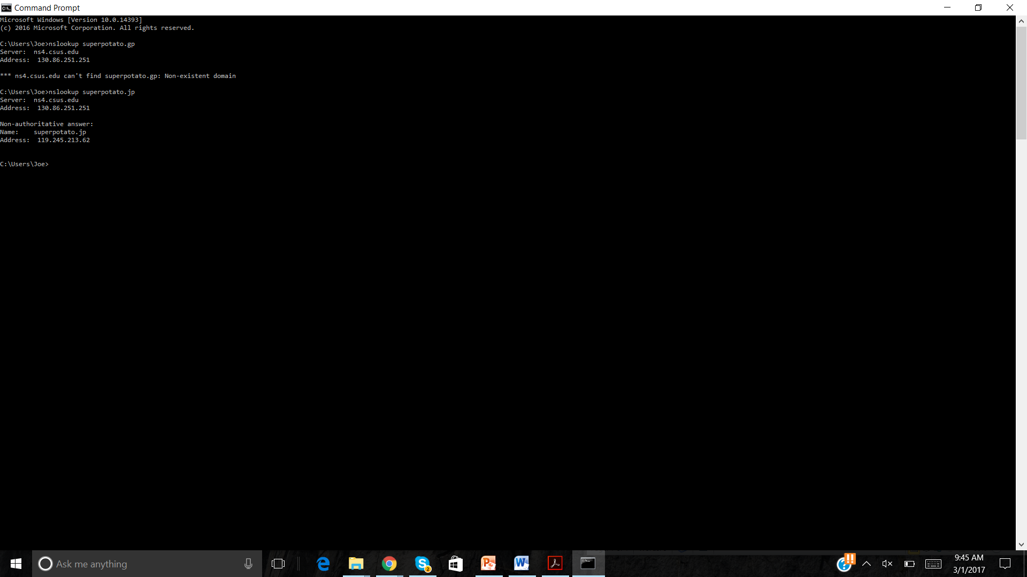

1. **Dns.hosteurope.de**

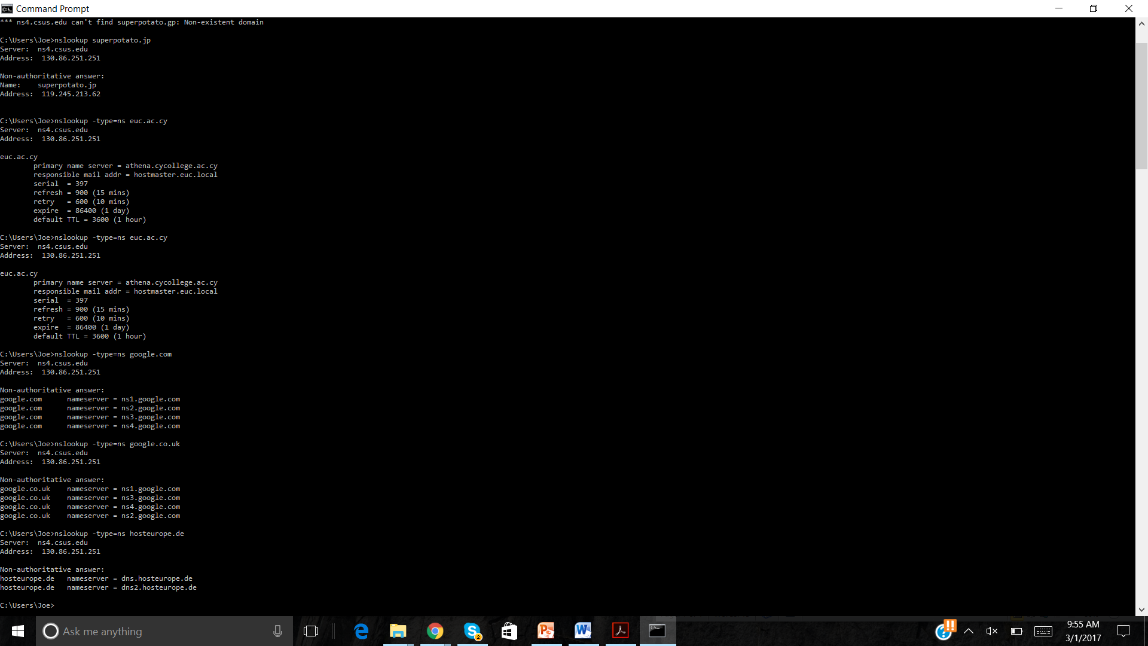

1. **68.142.255.16**

